- Please make dynamic
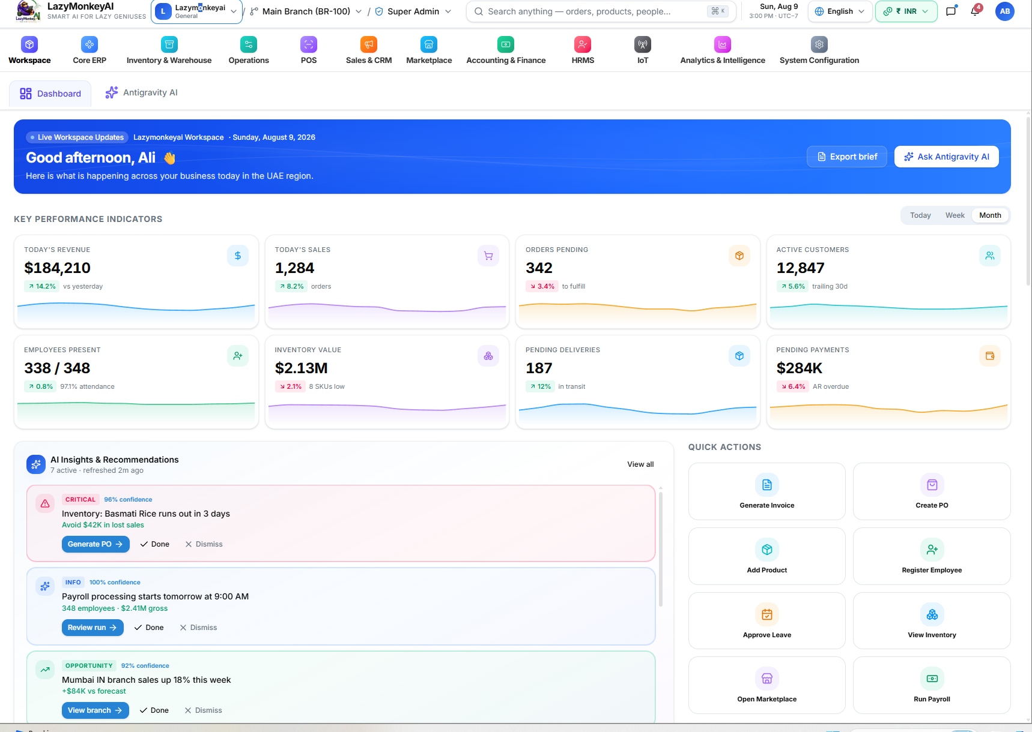
- Add customer with below fields
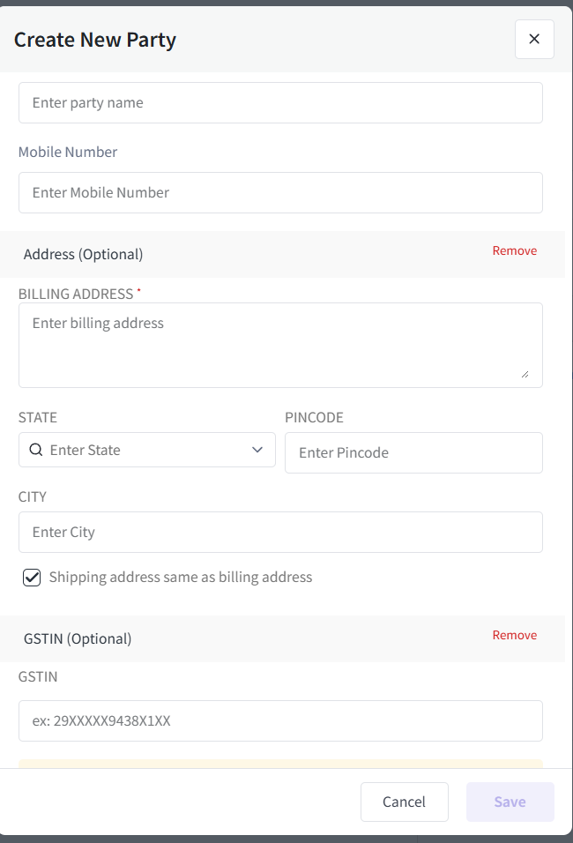
- Add additional charges , this is like transport charges in sales and POS 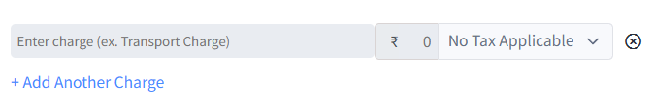
- Add create new product in sales and POS

- Add pay later in sales and POS
- Failed to generate Bill
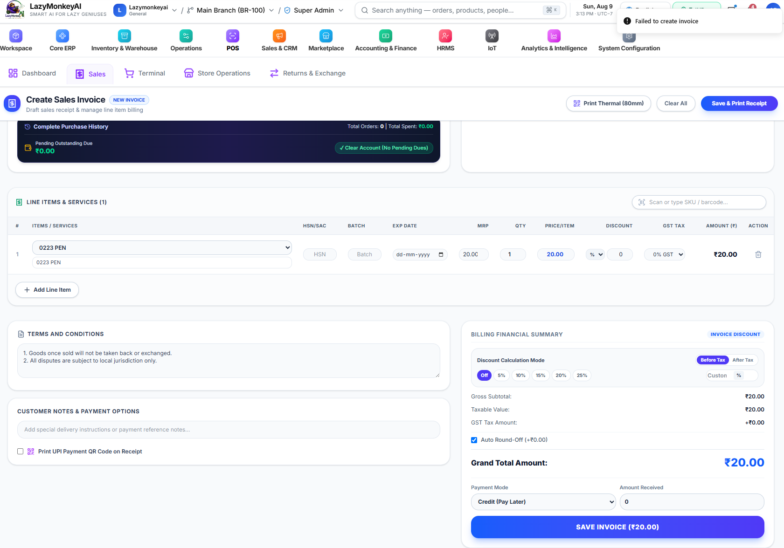
- For purchase request, purchase order, request for quotation and Purchase Returns
- below screen is going to user in the place of customer is going to use Vendor. All these will map with sequence number. Check credit note and all in my bill as reference.no exchange only sales return.there will be option drop down select from where is going goods ware house or store v/s for sales or purchase.retail is default only will select Whole sale and B2B.
Nageswari please add sales team points also
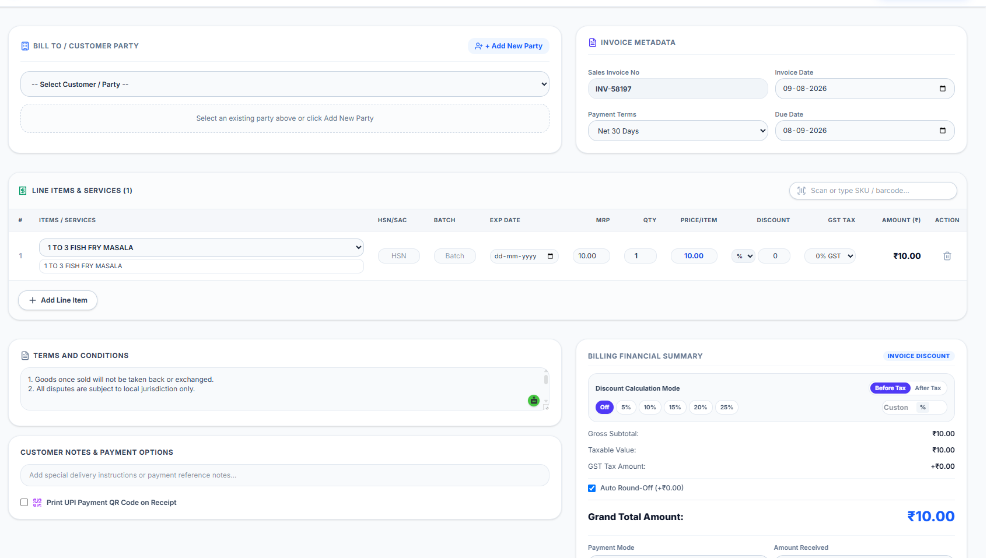
- Add item, discount and charges. Category and sub category data not populating
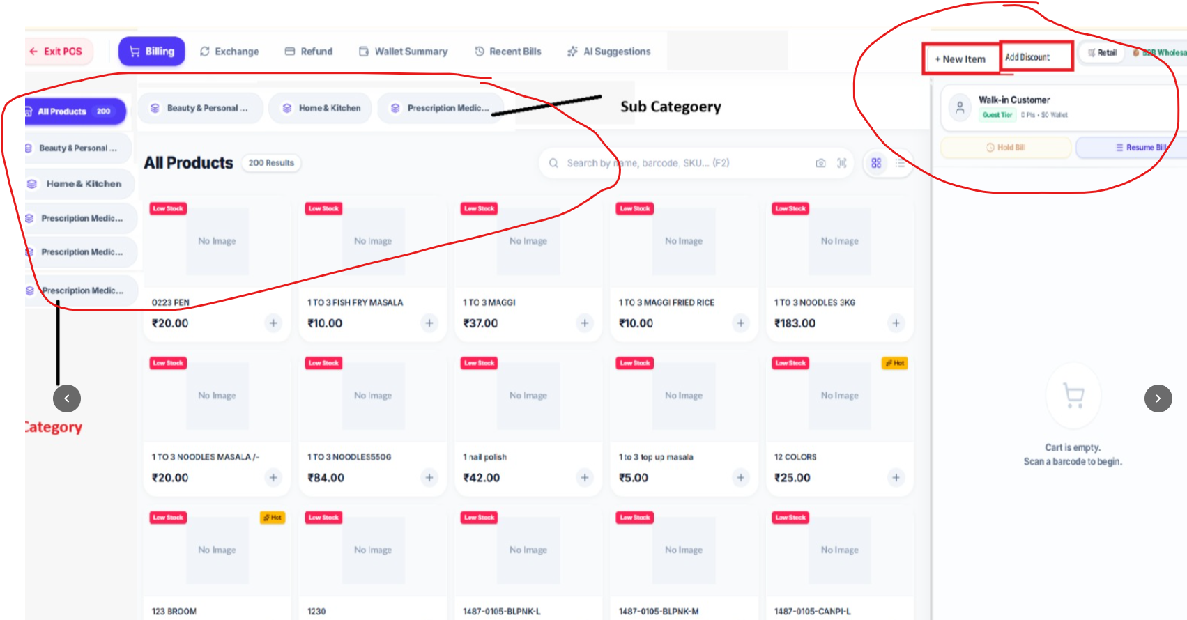
- Please test other modules step by step and create ecommerce 4 to 5 models with integration.
- Please add all apis and test, please let me know what required.

